Day 1
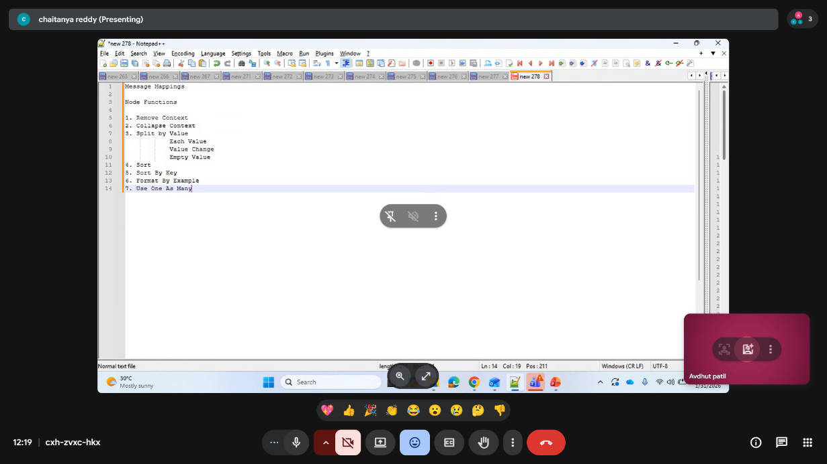
XML Does Not Use Predefined Tags
https://www.w3schools.com/xml/xml_whatis.asp
UTF-8 is the default character encoding for XML documents.

The XML language has no predefined tags.
The tags in the example above (like <to> and <from>) are not defined in any XML standard. These tags are "invented" by the author of the XML document.
HTML works with predefined tags like <p>, <h1>, <table>, etc.
With XML, the author must define both the tags and the document structure.
1) XML was designed to store and transport data
2) XML above does not DO anything. XML is just information wrapped in tags.
XML Simplifies Things
- XML simplifies data sharing
- XML simplifies data transport
- XML simplifies platform changes
- XML simplifies data availability
With XML, data can be available to all kinds of "reading machines" like people, computers, voice machines, news feeds, etc.

Transaction Data
Thousands of XML formats exist, in many different industries, to describe day-to-day data transactions:
- Stocks and Shares
- Financial transactions
- Medical data
- Mathematical data
- Scientific measurements
- News information
- Weather services
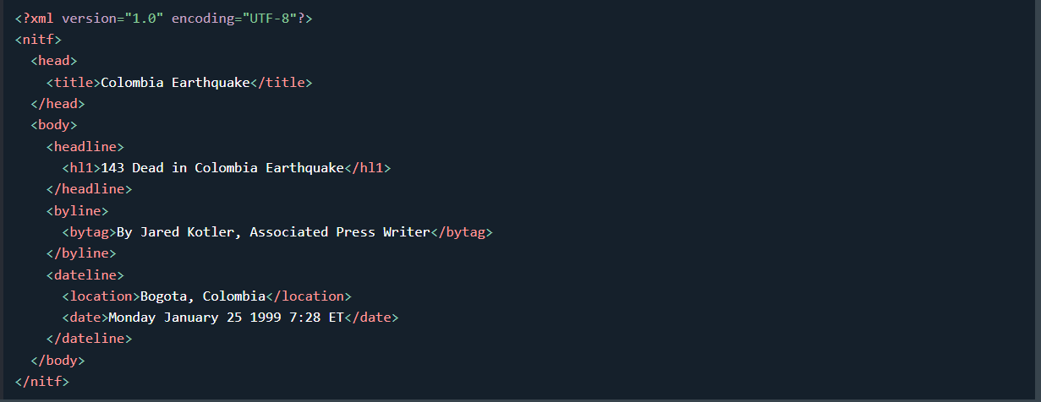

🔹 XML Entity References – Short Summary
- Some characters like <, >, &, ', " have special meaning in XML
- Using them directly inside XML causes parsing errors
- To avoid errors, XML uses entity references
✅ Predefined XML Entity References
- &lt; → < (less than)
- &gt; → > (greater than)
- &amp; → & (ampersand)
- &apos; → ' (apostrophe)
- &quot; → " (quotation mark)
🎯 Example
<message>salary &lt; 1000</message>
Entity references ensure XML remains valid and readable by parsers.

Root element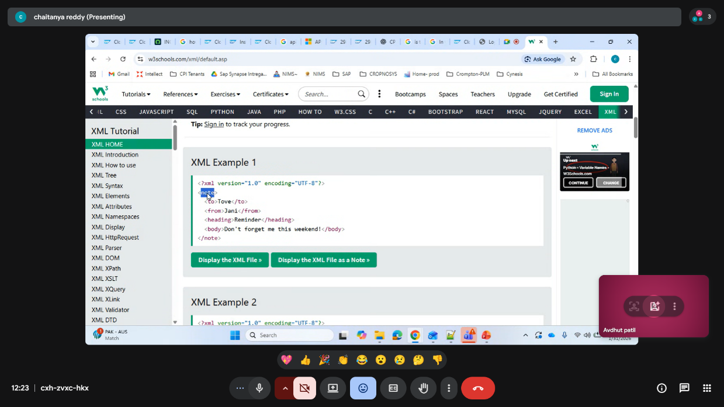

Subroot element (inside it fields and field values )
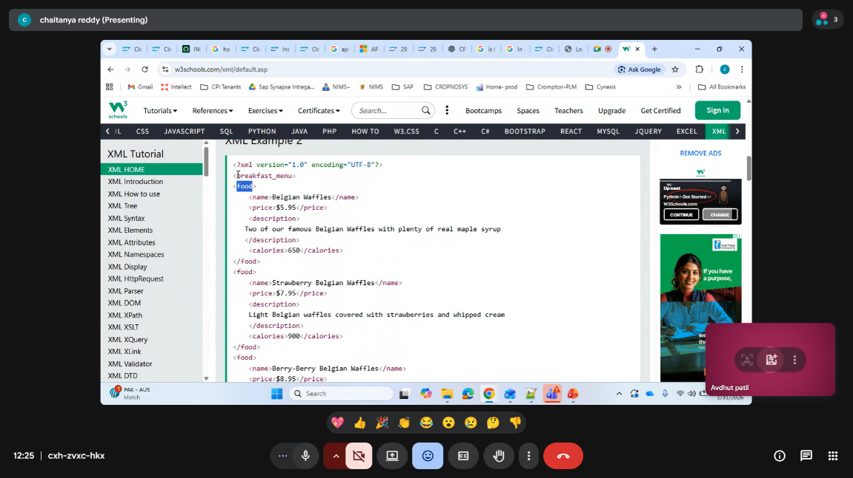

One line element
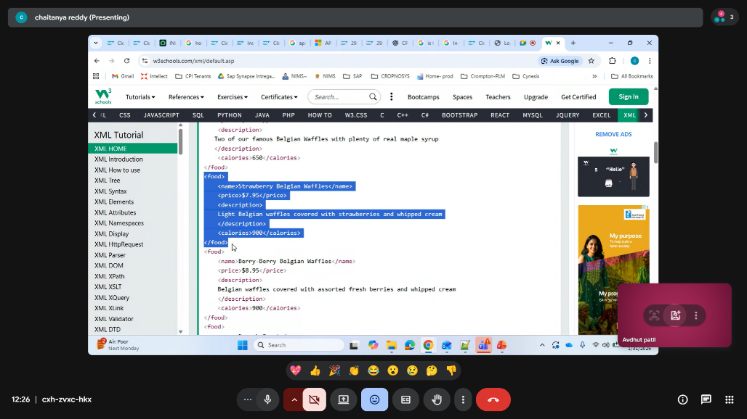

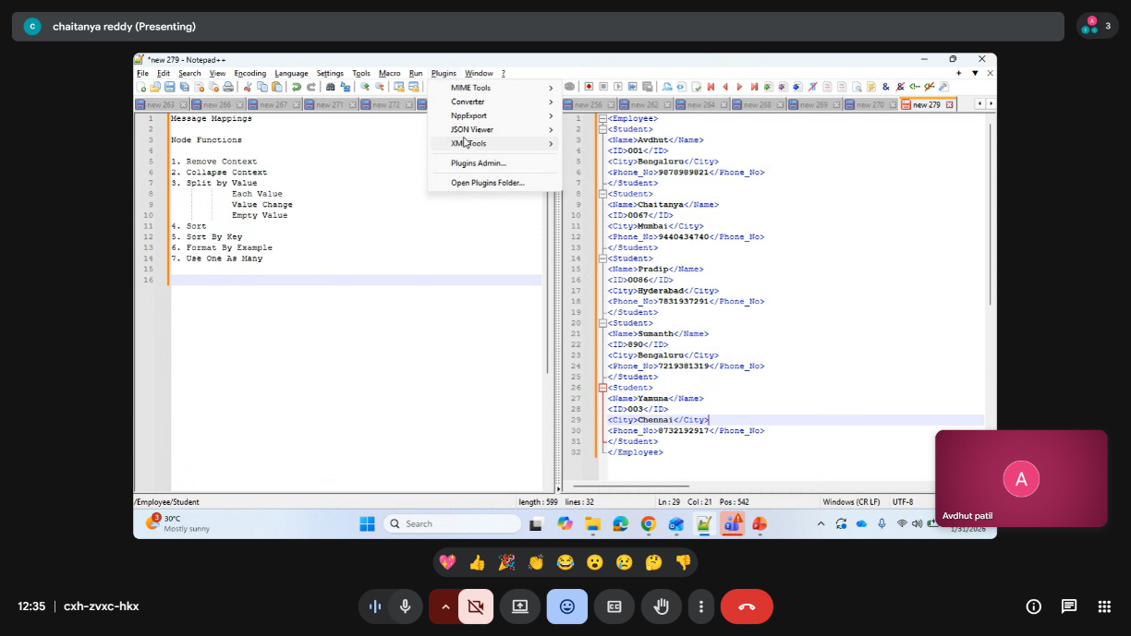

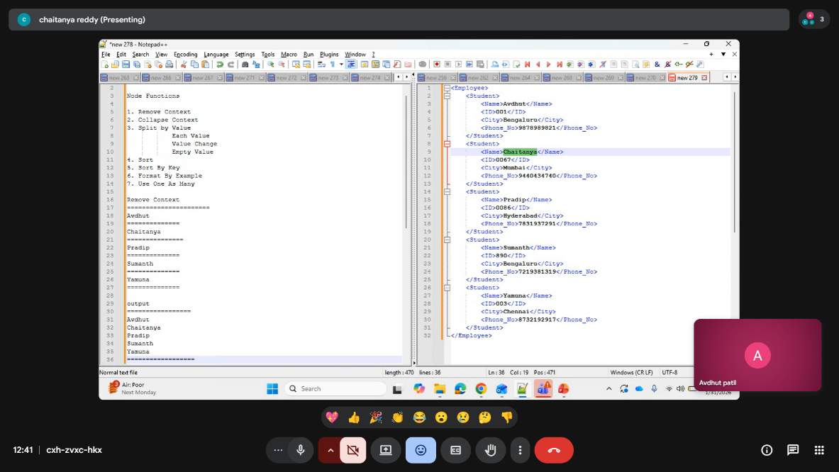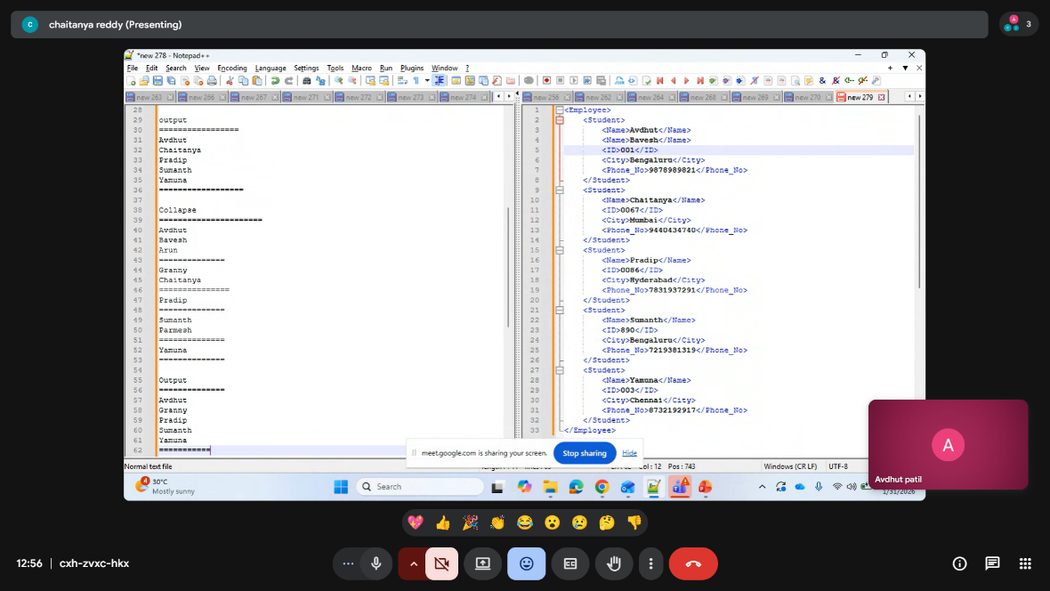
<?xml version="1.0" encoding="UTF-8"?>
<breakfast_menu>
<food>
<name>Belgian Waffles</name>
<name>Belgian Waffles</name> repeating fields is allowed
<price>$5.95</price>
<description>
Two of our famous Belgian Waffles with plenty of real maple syrup
</description>
<calories>650</calories>
</food>
<food>
<name>Strawberry Belgian Waffles</name>
<name1>Strawberry Belgian Waffles</name1> But introducing new field is not allowed
<price>$7.95</price>
<description>
Light Belgian waffles covered with strawberries and whipped cream
</description>
<calories>900</calories>
</food>
<food>
<name>Berry-Berry Belgian Waffles</name>
<price>$8.95</price>
<description>
Belgian waffles covered with assorted fresh berries and whipped cream
</description>
<calories>900</calories>
</food>
- </breakfast_menu>
Xslt formate
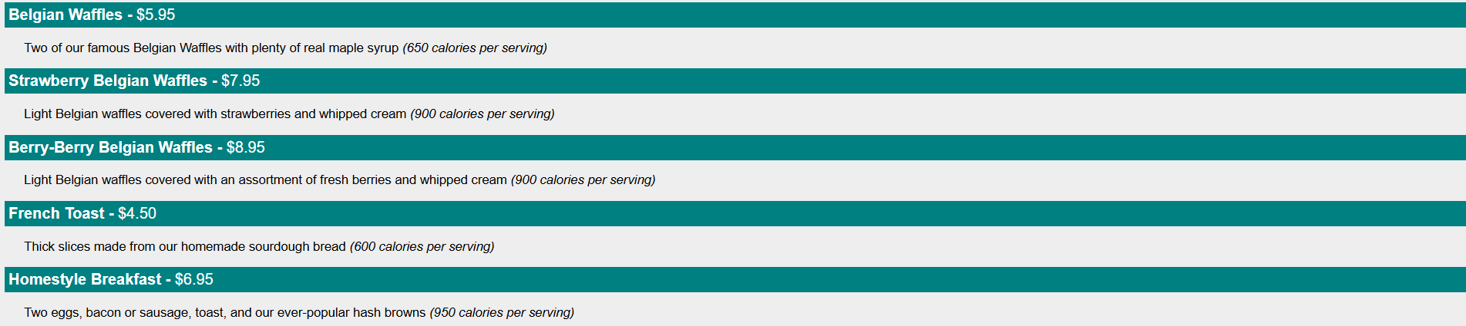
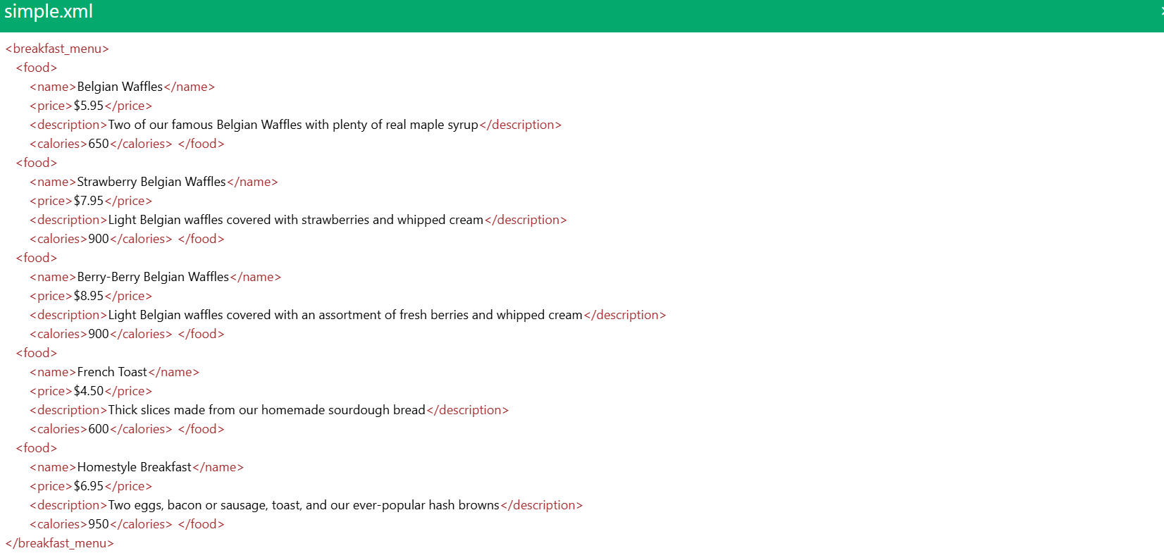
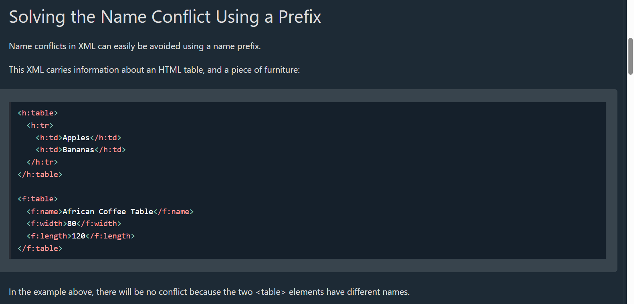

XSLT elements are predefined tags used in XSLT (Extensible Stylesheet Language Transformations) to transform XML data into another format (XML, HTML, text, JSON-like text, etc.).
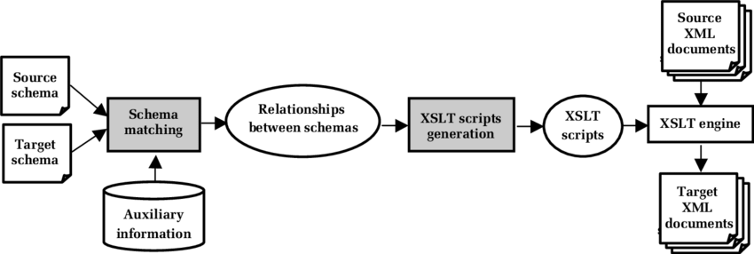

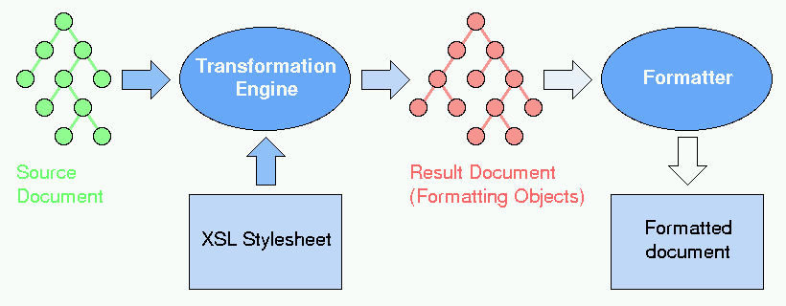
Below is a point-wise, exam/interview-friendly list 👇
(keeping it crisp, as you prefer)

🔹 Core XSLT Elements
1️⃣ <xsl:stylesheet> / <xsl:transform>
- Root element of an XSLT file
- Defines XSLT version
<xsl:stylesheet version="1.0"
xmlns:xsl="http://www.w3.org/1999/XSL/Transform">

2️⃣ <xsl:template>
- Defines rules for matching XML nodes
- Heart of XSLT
<xsl:template match="/">

3️⃣ <xsl:apply-templates>
- Calls templates for child nodes
- Enables recursive processing
<xsl:apply-templates select="book"/>

4️⃣ <xsl:value-of>
- Extracts and outputs text value
<xsl:value-of select="title"/>

5️⃣ <xsl:for-each>
- Loop through multiple XML nodes
<xsl:for-each select="books/book">

🔹 Conditional & Logic Elements
6️⃣ <xsl:if>
- Simple condition check
<xsl:if test="price &gt; 500">

7️⃣ <xsl:choose>
- Works like if–else
<xsl:choose>
<xsl:when test="price &gt; 500"/>
<xsl:otherwise/>
</xsl:choose>

🔹 Output & Formatting
8️⃣ <xsl:output>
- Defines output format (HTML, XML, text)
<xsl:output method="html"/>

9️⃣ <xsl:text>
- Outputs static text
<xsl:text>Price:</xsl:text>

🔹 Variables & Parameters
🔟 <xsl:variable>
- Stores values (read-only)
<xsl:variable name="tax" select="0.18"/>

1️⃣1️⃣ <xsl:param>
- Accepts external input (runtime parameter)
<xsl:param name="currency"/>

🔹 Sorting & Advanced
1️⃣2️⃣ <xsl:sort>
- Sorts data inside loops
<xsl:sort select="price" order="ascending"/>

1️⃣3️⃣ <xsl:call-template>
- Calls a named template
<xsl:call-template name="header"/>

🔹 One-Line Summary (Interview Tip 🎯)
XSLT elements are built-in tags that define how XML data is selected, processed, and transformed into another structured output.

If you want, I can also give:
- ✅ XSLT elements used in SAP CPI
- ✅ Real-time example (XML → HTML)
- ✅ XSLT interview questions
- ✅ Cheat sheet PDF
Just tell me 👍

